S-127: Pilot Services Data Collation

book3

# Questions

* Where can repetition be reduced?
* How can this data be reused (effectively…so it maintains its details based on location)?
* How can this be set up as one feature with many attributes?

## Coast Pilot Questions

* How can I tell which pilot boat description belongs to which service?

## Coast Pilot comments

* Reading this to fill in data structures made it clear how *unclear* much of the text is and how difficult it is to understand when completely unfamiliar with the area being spoken about and the services being offered. There are places where a pilot boat is described and it leaves the reader unsure of exactly which services use that exact boat, everything in the chapter, in the immediate preceding or following paragraphs? Forcing the text into the S-127 data structure eliminates the ambiguity I found in many of the Coast Pilot paragraphs.

## S-127 questions

* I have multiple pilot boats that belong to the specific service and go to specific destinations, however, the destination information is located in Pilot Boarding place…I would have expected destination to be associated with the service…in case there is more than one. For example: I have a pilot boarding place that (it appears) many pilots start at, but their destinations vary. Also, they will have pilot boarding places at every port …what is important to keep track of? Every boarding place, or only the ones at the designated area on the chart? (If yes to the latter, then how to encode as a side note all the other boarding places for that service?)
* I found myself using both ContactDetails communicationChannel as well as radiocommunications->communicationChannel. The benefit of the latter is that I can then also associated the categoryOfRadioMethods with it. SO I began to wonder which should I use? What was the intention for either?

## S-127 comments

* I created a work around to accommodate the service visiting multiple destinations…just an example of how the data structure could be exploited to serve a specific need….or as a place holder for a possible future upgrade.
* I also used the textContent for my own internal purposes to keep backward compatibility with the current publication system. I have maintained a consistent naming scheme so it could be programmatically interpreted/anticipated.
  1. <headline>Destination</headline>
  2. <headline>Availability</headline>
  3. <headline>Phone Hours</headline>
  4. <headline>Additional Information</headline>
  5. <headline>Services Provided </headline>
  6. <headline>Communications</headline>
  7. <headline>Meeting Place</headline>
  8. <headline>Advance Pilot Orders</headline>
  9. <headline>River Pilot Only</headline>
  10. <headline>PRECAUTIONARY AREA (note C)</headline>
  11. <headline>Boat Location</headline>
  12. <headline>Number of Boats</headline>
  13. <headline>Radio Monitoring</headline>
* It helps GREATLY to come up with consistently formed, semi-human readable gml:id’s when it comes to creating associations and linking items together. For example in this one I settled (for now) on using CB for Chesapeake Bay then the S-100 acronym for the item (like PILBOP - pilot boarding place or PERM – permission), then a dataset name and long name for ENC objects or a clear convention to understand what the item represents (like required.foreign for permission). When I named services it was easy to use the same Acronym for authority, contact details, etc and referencing them later was much more intuitive.

Note: applicability type is where vessel measurements are. Can I use this for the pilot boat description? I would like to attach it to a pilot boarding place.

# ENC reference

PILBOP is in PortsAndServicesA

I also exploited the gml:id by using it to connect to the ENC features so they can be linked/referenced somehow. I did it based on the US ENC for the area, using the dataset name and the long name. Often I would also add a .FCSUBTYPE to qualify a point or area being referenced in an ENC.

# Original Text from entire book 3

The following is a collation of everything that relates to pilot services within the Coast Pilot book 3. Keeping the chapters and paragraph numbers intact for reference and as an aid to build a proof-of-concept system that will ultimately generate similar paragraphs from the S-127 dataset.

The items entered into the S-127 gml structure were highlighted by means of color-coding to ensure all data was captured and where it exists within the structure. This helped greatly in becoming more familiar with the contents of the data and structure as well as to tackle certain themes one at a time.

## Items in Data structure

Color key

ContactDetails

Authority

Applicability/permissionType

PilotDistrict

PilotService

PilotBoardingPlace

ServiceHours

## chapter 3

(221) Pilotage, general

(222) *Pilotage is compulsory for all foreign vessels* *and U.S. vessels under register in the foreign trade.* *Pilotage is optional for coastwise vessels that have on board a pilot properly licensed by the Federal Government for the waters which the vessel travels.*

(223) The Maryland Pilots maintain a pilot station at Cape Henry; Virginia State pilots maintain a pilot station at Cape Henry; pilots for Delaware Bay and River maintain a pilot station at Cape Henlopen; Maryland State pilots and pilots for Delaware Bay and River also maintain a joint pilot station at Chesapeake City, MD, on the Chesapeake and Delaware Canal.

(224) The Chesapeake and Interstate Pilots Association *offers pilotage to U.S. vessels engaged in the coastwise trade. Pilotage is also available to public vessels*. The association serves vessels transiting Chesapeake Bay and its tributaries, Chesapeake and Delaware Canal, and Delaware Bay and River. Chesapeake and Interstate Pilots Association has an office in Norfolk (telephone, 757-855-2733).

(225) The Interport Pilots Agency, Inc., *offers pilotage to public vessels and private vessels in the coastal trade* transiting the Delaware Bay and River, Chesapeake and Delaware Canal, Upper Chesapeake Bay, New York Harbor, Long Island Sound and other areas along the northeast coast. Arrangements for their services are made 24 hours in advance through the ship’s agents or by contacting Interport Pilots Agency, Inc., 906 Port Monmouth Road, Port Monmouth, NJ 07758-0236, telephone 732-787-5554 (24 hours), or by email at interport@verizon.net. Additional information about Interport Pilots can be obtained at interportpilots.com.

(226) Pilotage is available for foreign vessels and U.S. vessels under register, for all ports on the New Jersey seacoast from Sandy Hook to and including Atlantic City, from the Sandy Hook Pilot Association, 201 Edgewater Street, Staten Island, NY 10305.

(227) Telephone 718-448-3900, fax 718-447-1582;

(228) Email: PILOTOFFICE@sandyhookpilots.com. A 24-hour advance notice is required.

(229) All pilot associations provide 24-hour service. Arrangements for pilots should be made well in advance through ships’ agents.

(230) Detailed information on pilotage procedures is given in the text for the ports concerned.

## Chapter 4

(20) Pilotage, New Jersey Coast

(21) Pilotage is compulsory for foreign vessels and U.S. vessels under register. Pilotage is available from the Sandy Hook Pilot Association, 201 Edgewater Street, Staten Island, NY 10305, telephone 718-448-3900, fax 718-447-1582, email: pilotoffice@sandyhookpilots.com. Arrangement for pilotage may be made through ship’s agents or directly. A 24-hour advance notice is required.

(36) Pilotage, Shark River Inlet

(37) Pilotage is compulsory for foreign vessels and U.S. vessels under register. Pilotage is available from the Sandy Hook Pilot Association, 201 Edgewater Street, Staten Island, NY 10305, telephone 718-448-3900, fax 718-876-8055, email: pilotoffice@sandyhookpilots.com. Arrangements for pilotage may be made through ship’s agents or directly. A 24-hour advance notice is required.

(43) Pilotage, Manasquan Inlet

(44) Pilotage is compulsory for foreign vessels and U.S. vessels under register. Pilotage is available from the Sandy Hook Pilot Association, 201 Edgewater Street, Staten Island, NY 10305, telephone 718-448-3900, fax 718-876-8055, e-mail: pilotoffice@sandyhookpilots.com. Arrangements for pilotage may be made through ship’s agents or directly. A 24-hour advance notice is required.

(67) Pilotage, Atlantic City

(68) Pilotage is compulsory for foreign vessels and U.S. vessels under register. Pilotage is available from the Sandy Hook Pilot Association, 201 Edgewater Street, Staten Island, NY 10305, telephone 718-448-3900, fax 718-876-8055, e-mail: pilotoffice@sandyhookpilots. com. Arrangements for pilotage may be made through ship’s agents or directly. A 24-hour advance notice is required.

(90) Pilotage, Cape May Harbor

(91) Pilotage is compulsory for all foreign vessels of 100 gross tons or more and all U.S. vessels under register engaged in foreign trade or commerce of 100 gross tons or more. Pilotage is optional for all U.S. Government vessels and for all U.S. vessels under enrollment in a coastwise trade if they have on board a pilot licensed by the Federal Government to operate in these waters. Pilotage service is available from the Pilots’ Association for Bay and River Delaware on a limited 24-hour basis. Arrangements for pilotage can be made through ships’ agents or directly. A 24-hour advance notice is requested with updated 6-hour ETA. Pilots will board just southwestward of Lighted Bell Buoy 2CM off Cape May Inlet. (See Pilotage, Bay and River Delaware, Chapter 6.)

## Chapter 5

(35) Pilotage, Manasquan Inlet

(36) Pilotage is compulsory for foreign vessels and U.S. vessels under register. Pilotage is available from the Sandy Hook Pilot Association, 201 Edgewater Street, Staten Island, NY 10305, telephone 718-448-3900, fax 718-876-8055, email: pilotoffice@sandyhookpilots.com. Arrangements for pilotage may be made through ship’s agents or directly. A 24-hour advance notice is required.

## chapter 6

(33) The pilot boarding area is about 2.5 miles southeastward of Cape Henlopen. (See pilotage later in

this chapter.)

(60) Pilotage, Delaware Bay and River

(61) Pilotage on Delaware Bay, Delaware River and tributaries thereof is compulsory for all foreign vessels of 100 gross tons or more and all U.S. vessels under register engaged in the foreign trade or commerce of 100 gross tons or more. Pilotage is optional for all U.S. Government vessels and for all U.S. vessels in the coastwise trade that have on board a pilot licensed by the Federal Government for these waters.

(62) Pilot services are provided on a 24-hour basis by the Pilots’ Association for the Bay and River Delaware, Chesapeake and Interstate Pilots Association (Federal Pilots) and Interport Pilots Agency, Inc. (Federal Pilots).

(63) The Pilots’ Association for the Bay and River Delaware maintains its office in Philadelphia, PA, a pilot station in Lewes, DE, and a pilot watch tower on Cape Henlopen. The office address is 800 South Columbus Blvd., Philadelphia, PA 19147; telephone, 215–465–8340; fax, 215–465–3970; cable, DELPILOTS in Philadelphia; and email address: dispatch@delpilots.com. The pilot station address is 41 Cape Henlopen Drive, Lewes, DE 19958; telephone, 302–645–2228; fax, 302–645–7822. The pilot watch tower at Cape Henlopen’s telephone number is 302–645–8538; fax, 302–645–1728. Pilots are generally arranged for in advance through ships’ agents and board incoming vessels from the pilot boat in the pilot boarding area off Cape Henlopen. Vessels are requested to contact pilots when inbound at either Delaware Lighted Buoy D or Five Fathom Bank Lighted Buoy F; both buoys are equipped with a racon. Vessels not requiring pilots are requested to contact “Cape Henlopen Tower” one hour prior to entering or departing Delaware Bay.

(64) The pilot boats are 50 feet long with black hulls and white houses with the word “PILOT” in large letters on each side. The pilot station and pilot boats may be contacted on VHF-FM channels 14 and 16. The pilots carry portable radiotelephones for bridge-to-bridge communications on VHF-FM channel 13.

(65) The Pilots’ Association for the Bay and River Delaware also provides qualified offshore “advisors” for the deepest draft vessels between Lighted Buoy “D” and the anchorage areas in Delaware Bay. A notice of 24 hours before estimated arrival is requested for this service

(66) The Chesapeake and Interstate Pilots Association offers pilot services to U.S. vessels engaged in the coastwise trade and to public vessels between Cape Henlopen, Philadelphia and Delair. Arrangements for pilots are made through ships’ agents or the pilot office in Norfolk (telephone, 757–855–2733). Pilots use commercial launch services and will meet vessels in the Pilotage Area off Cape Henlopen. Pilots arrive at the launch one hour prior to arrival and monitor VHF-FM channel 16 one hour prior to last ETA. Cellular telephone confirmation with the pilot office in Norfolk or the launch service can be made at 302–422–7604 if radio contact is unsuccessful. Advance pilot ordering with a 6-hour ETA update and any subsequent changes is requested.

(67) The Interport Pilots Agency, Inc. offers pilotage to public vessels and private vessels in the coastal trade transiting the Delaware Bay and River, Chesapeake and Delaware Canal, Upper Chesapeake Bay, New York Harbor, Long Island Sound and other areas along the northeast coast. Arrangements for their services are made 24 hours in advance through the ship's agents or by contacting Interport Pilots Agency, Inc., 906 Port Monmouth Road, Port Monmouth, NJ 17758–0236, telephone 732–787–5554 (24 hours), or by e-mail at interport@verizon.net. Additional information about Interport Pilots can be obtained at interportpilots.com.

(68) Pilots meet vessels at the pilot boarding area off Cape Henlopen **using Delaware Bay Launch Service**, which monitors VHF-FM channels 16 and 9. Their (24 hour) phone number is: 302–422–7604. Additional information about Delaware Bay Launch Service may be found at delawarebaylaunch.com.

## chapter 7

(88) Pilotage, Chesapeake and Delaware Canal

(89) Pilotage through the canal from Delaware River to Chesapeake City is provided by the Pilots’ Association for the Delaware Bay and River. ~~(See Pilotage, Bay and River Delaware, indexed as such, Chapter 6.)~~ Pilotage from Chesapeake City to Maryland ports and to Washington, D.C., is provided by the Association of Maryland Pilots~~. (See Chapter 15.)~~ Both pilots associations maintain a common station on the north bank of the canal at Chesapeake City. A white motor launch is used for exchanging pilots in the general vicinity of Chesapeake City. Vessels proceeding from Chesapeake City to Washington, D.C., or the lower part of Chesapeake Bay, when using Maryland pilots, sometimes transfer pilots at a designated transfer area in Chesapeake Bay off the entrance to Patuxent River or on the Potomac River off Piney Point, depending on the port of call.

(90) The Maryland pilots are replaced by Virginia pilots off the entrance of the Patuxent River or on the Potomac River off Piney Point, depending on the port of call.

(91) The Interport Pilots Agency, Inc., offers pilotage to public vessels and private vessels in the coastal trade transiting the Chesapeake and Delaware Canal and continuing to ports in the Delaware Bay and River, Upper Chesapeake Bay, New York Harbor and Long Island Sound. They board vessels at any Delaware River or Upper Chesapeake Bay port, the pilot boarding area off Cape ~~Henlopen as described in Chapter 6,~~ or at the Reedy Point Anchorage near the east end of the Chesapeake and Delaware Canal. Arrangements for pilot services are made 24 hours in advance with a 6-hour ETA update through the ships agent or with Interport Pilots Agency, Inc., 906 Port Monmouth Road, Port Monmouth, NJ 07758-0236, telephone 732–787–5554 (24 hours), or email at interport@verizon.net. Additional information about Interport Pilots can be obtained at: interportpilots.com.

(92) The Chesapeake and Interstate Pilots Association offers pilot services to U.S. vessels engaged in the coastwise trade and to public vessels transiting the Chesapeake and Delaware Canal. Pilots will meet vessels between Cape Henlopen, any port or place on the Delaware Bay and River, or any port or place on the Chesapeake Bay and its tributaries and provide all pilot services required when vessels use the canal. Arrangements for pilots are made through ships’ agents or the pilot office in Norfolk (telephone, 757–855–2733). The pilots use commercial launch services. Advance pilot orders requested with 6-hour ETA update and any subsequent changes requested. Pilots will get underway generally 30 minutes prior to the time they have been ordered.

(93) All pilots carry radiotelephones for bridge-to-bridge communications and for communications with the canal traffic dispatcher at Chesapeake City. Delaware Bay and River pilots use VHF-FM channel 14, and the Maryland pilots use VHF–FM channel 11; all associations use VHF-FM channel 13.

## chapter 9

(52)**Pilotage,** Chesapeake Bay

(53) Pilotage is compulsory for all foreign vessels and for U.S. vessels under register in the foreign trade. Pilotage is optional for U.S. vessels under enrollment in the coastwise trade if they have on board a pilot licensed by the Federal Government to operate in these waters.

(54) The Association of Maryland Pilots has an office in Baltimore (email: dispatch@mdpilots.com, telephone: 410-342-6013, fax: 410-276-1364). They provide service to any port in Maryland and service between Cape Henry, VA, to Baltimore and between Baltimore and the Head of the Chesapeake Bay including to Chesapeake City in the C&D Canal. Transmit ETA 72 hours with confirmation/updates 24, 12 and 6 hours before arrival pilot station. Email ETA, transit speed, and draft to: dispatch@mdpilots.com. The Virginia Pilots Association has an office in Norfolk (telephone: 757-496-0995) and provides service to any port in Virginia. Vessels bound for Washington, DC, may take a pilot from either association.

(55) The Maryland pilots maintain a Pilot Tower with the Virginia pilots at Cape Henry, just north of Cape Henry Light. The pilots monitor VHF-FM channels 11, 13 and 16. The pilot boats are stationed in Lynnhaven Inlet. They are 52 feet long with a black hull and white house displaying the “PILOT” on each side.

(56) The Virginia Pilots Association maintains a pilot station at Cape Henry, just north of Cape Henry Light. The pilots monitor VHF-FM channels 11, 16 and 74. Other channels are used on request. Email address: DISPATCH@PILOT.INFI.NET. Four pilot boats are stationed in Lynnhaven Inlet; two are in use at any given time. The pilot boats are 50 feet long with orange hulls and gray houses with the word “PILOT” on each side.

(57) The Chesapeake and Interstate Pilots Association offers pilot services to vessels engaged in the coastwise trade and public vessels between Cape Henry and various ports and places on the Chesapeake Bay and its tributaries. Arrangements for pilots are made through ships’ agents

or the pilot office in Norfolk (telephone: 757-855-2733). The pilots board from the pilot boat Chesapeake, which is 41 feet long, gray hull with white superstructure and the word “PILOT” on the side. Pilot ladders are recommended to be rigged 4 feet above the water on the leeward side.

The pilot vessel monitors VHF-FM channels 13 and 16, 90 minutes prior to the last ETA received. Cellular confirmation of arrival is recommended if radio contact is not successful.

(58) Vessels are boarded in the Pilot boarding area off Cape Henry.

(59) It has been noted that sometimes considerable differences occur between a vessel’s ETA and her actual arrival due to conditions encountered between Cape Hatteras and Cape Henry. Revisions to the ETA of 1 hour or greater should be passed to the pilots especially if the vessel’s arrival will be sooner than previously advised.

(93) Pilotage

(94) Pilotage for Hampton Roads ports. (See Pilotage at the beginning of this chapter and Chapter 3.)

## chapter 10

(18) Pilotage, James River

(19) Pilotage on the James River is compulsory for all foreign vessels and for U.S. vessels under register in the foreign trade. Pilotage is optional for U.S. vessels in the coastwise trade that have on board a pilot licensed by the Federal Government to operate in these waters.

(20) The Chesapeake and Interstate Pilots Association offers pilot services to vessels engaged in the coastwise trade and public vessels to any port or place on the James River. Chesapeake and Interstate Pilots Association offers some pilot service in the upper James River at night. Arrangements for pilots may be made through ships’ agents or the pilot office in Norfolk (telephone, 757–855–2733). Vessels requesting a river pilot only are boarded off Sewells Point. Pilots from sea are boarded at Cape Henry. Pilots use commercial launch services. Pilots begin radio watches at the launch service on VHFFM channel 16, 30 minutes prior to last ETA. Advance pilot orders requested with 3-hour ETA update and any subsequent changes requested.

(21) The Virginia Pilots Association offers pilotage to all vessels. Pilot service for the upper 38 miles of the river is available only during daylight. (See Pilotage, Chapters 3 and 9.)

## chapter 11

(40) Pilotage, York River

(41) Pilotage on the York River is compulsory for all foreign vessels and for U.S. vessels under register in the foreign trade. Pilotage is optional for U.S. vessels in the coastwise trade that have on board a pilot licensed by the Federal Government to operate in these waters.

(42) The Chesapeake and Interstate Pilots Association offers pilot services to U.S. vessels, engaged in the coastwise trade, and public vessels to Yorktown. Arrangements for pilots may be made through ships’ agents or the pilot office in Norfolk (telephone, 757–855–2733). Pilots will meet vessels entering from sea at Cape Henry (discussed in Chapter 9) and will meet a vessel at its port if it is on the Chesapeake Bay and its tributaries or Delaware Bay and River and provide pilot services directly to the York River. The Virginia Pilots Association offers pilotage to all vessels. Pilot service above Cheatham Annex is available only during daylight. (See Pilotage, Chapters 3 and 9.)

## Chapter 12

(29) Pilotage, Potomac River

(30) Pilotage is compulsory on the Potomac River for foreign vessels and U.S. vessels under register in the foreign trade. Pilotage is optional for U.S. vessels in the coastwise trade who have on board a pilot licensed by the Federal Government for these waters.

(31) The Chesapeake and Interstate Pilots Association offers pilot services to U.S. vessels engaged in the coastwise trade and public vessels to Piney Point. Arrangements for pilots may be made through ships’ agents or the pilot office in Norfolk (telephone, 757-855-2733). Pilots will meet vessels entering from sea at Cape Henry (discussed in Chapter 9) and will meet a vessel at its port if it is on the Chesapeake Bay and its tributaries or Delaware Bay and River and provide all pilot services directly to the Potomac River. Pilots may meet vessels off the Patuxent River or off the mouth of the Potomac River with sufficient coordination. Contact the pilot office for information.

(32) The Virginia Pilots Association offers pilotage to any vessel bound for a port in Virginia or Washington, DC. The Association of Maryland Pilots offers pilotage to any vessel bound for a port in Maryland or Washington, DC. (See Pilotage, Chapters 3 and 9.)

## Chapter 15

(51) Pilotage, Baltimore

(52) Pilotage is compulsory for all foreign vessels and for U.S. vessels under register in the foreign trade bound to or from the port of Baltimore. Pilotage is optional for U.S. vessels under enrollment in the coastwise trade that have on board a pilot licensed by the Federal Government for these waters.

(53) The Association of Maryland Pilots has an office in Baltimore (telephone: 410–276–1337, fax: 410–276–364, telex: 87–574 MARPILOTS BALTIMORE, cable address: MARPILOT BALTIMORE). They provide service to any port in Maryland and service between Baltimore and the entrance of the Chesapeake Bay at Cape Henry, VA. The pilot office also monitors VHFFM channel 11.

(54) The Chesapeake and Interstate Pilots Association offers pilot services to U.S. vessels engaged in the coastwise trade and public vessels to or from Baltimore via the Chesapeake Bay if the vessel is entering from sea at Cape Henry or transiting between any port or place on the Chesapeake Bay and its tributaries. Pilot service is also offered to vessels to or from Baltimore that are transiting the Chesapeake and Delaware Canal. Pilots will meet vessels upon prior arrangement at Cape Henlopen or any port or place on the Delaware Bay and River, at Cape Henry or any port or place on the Chesapeake Bay and its tributaries. Pilots will also provide all pilot services required from the port of departure to the port of arrival. Arrangements for pilots may be made through the ships’ agents or the pilot office in Norfolk (telephone, 757–855–2733).

(55) Interport Pilots Agency, Inc., offers pilotage to public vessels and private vessels in the coastal trade

operating between Baltimore Harbor and many northeast ports via the Chesapeake and Delaware Canal. The 24-hour telephone number is 732–787–5554 and the email address is interport@verizon.net. Additional information about Interport Pilots can be obtained at interportpilots.com.

(56) Pilotage information for incoming vessels is given in Chapters 6, 7 and 9.

# Pilot Service Areas

This is just a grouping of all the words/locations that make up a pilot service area in the text. After extracting them from the entire book they can be collated under each service name to see (and create with lat/lng points) the actual bounds of that service.

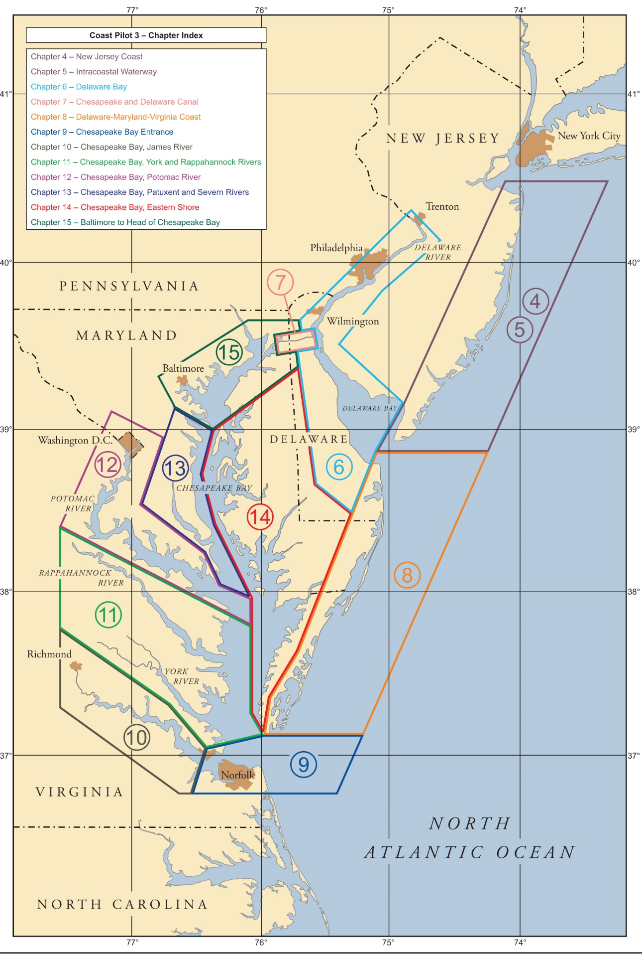

## Interport Pilots Agency, Inc.

### Chapter 3

Chesapeake and Delaware Canal

the Delaware Bay and River

Upper Chesapeake Bay

New York Harbor

Long Island Sound

other areas along the northeast coast.

### Chapter 6

Chesapeake and Delaware Canal

Delaware Bay and River

and tributaries thereof

Upper Chesapeake Bay

New York Harbor

Long Island Sound

Other areas along the northeast coast

### Chapter 7

Chesapeake and Delaware Canal

Ports in the Delaware Bay and River

Upper Chesapeake Bay

New York Harbor

Long Island Sound

### Chapter 15

operating between Baltimore Harbor and many northeast ports via the Chesapeake and Delaware Canal

## Sandy Hook Pilot Association

### Chapter 3

all ports on the New Jersey seacoast

from Sandy Hook

to and including Atlantic City,

with specific areas to include:

Shark River Inlet,

Manasquan Inlet

### Chapter 5

Manasquan Inlet

### Chapter 4

Cape May Harbor

### Chapter 6

Delaware Bay,

Delaware River

and tributaries thereof

### Chapter 7

Chesapeake and Delaware Canal

Through the canal from Delaware River to Chesapeake City

## Chesapeake and Interstate Pilots Association (Federal Pilots)

### Chapter 6

Delaware Bay

Delaware River

and tributaries thereof

Between Cape Henlopen, PA and Delair

### Chapter 7

Between Cape Henlopen and the following…

Chesapeake and Delaware Canal

Any port or place on the Delaware Bay and River

Upper Chesapeake Bay any port or place on the Chesapeake Bay and its tributaries

New York Harbor

Long Island Sound

### Chapter 10

Any port or place on the James River

### Chapter 11

Yorktown

provide pilot services directly to the York River

### Chapter 12

Potomac River to Piney Point.

### Chapter 15

to or from Baltimore via the Chesapeake Bay

if the vessel is entering from sea at Cape Henry

or transiting between any port or place on the Chesapeake Bay and its tributaries.

Chesapeake and Delaware Canal.

## Association of Maryland Pilots

### Chapter 7

from Chesapeake City to Maryland ports

and to Washington, D.C.

or the lower part of Chesapeake Bay

### Chapter 9

any port in Maryland

service between Cape Henry, VA, to Baltimore

between Baltimore and the Head of the Chesapeake Bay

including to Chesapeake City in the Chesapeake and Delaware Canal

### Chapter 12

Potomac River

bound for a port in Maryland

Or Washington, DC

### Chapter 15

service to any port in Maryland

and service between Baltimore and the entrance of the Chesapeake Bay at Cape Henry, VA.

## Virginia Pilots Association

### Chapter 9

Any port in Virginia

Bound for Washington, DC

### Chapter 10

James River

### Chapter 11

York River

### Chapter 12

Potomac River

bound for a port in Virginia

Or Washington, DC

# Notes on data structure

## Detailed descriptive text for attributes in the XSD file

Include the expected data type for the attribute along with an example where helpful. Examples will also help to guide an (optional) standardized way to enter the data. (if a text field)

## PilotVessel attribute to object.

I have noticed cases where multiple pilot services use the same launch service or vessel. I would like to be able to describe the pilot vessel in its own object so I would be able to separate the details of the vessel into one location and reuse that vessel if need be.

## TextContent id attribute

I found a precautionary area (note C) that was in the ENC that was also restated in the Coast Pilot text for a pilot boarding area. It also applies to a traffic lane, dumping grounds, restricted areas, etc. I think it would be valuable to be able to share these notes with MRN type identifiers so they could all point to the same original note.

## invInformationAssociation

just confused on if the invInformationAssociation can be reused by referencing the gml:id for it? If so, then how exactly? If not, then what would be the use/purpose for having a gml:id for it? It is a required element…but my file and the example S-127 file don’t reference it anywhere.

## Missing elements

### categoryOfVessel

I am looking for applicability of vessels to a pilotage District. option for categoryOfVessel to be ALL types! <categoryOfVessel>other: all types including barges</categoryOfVessel>

What about foreign vs. native?: all foreign vessels and for U.S. vessels under register in the foreign trade

#### Inverse of an item

In other words a way to say the one you selected is the only one NOT Applicable.

## Elements that could have more refined components

### ShipReport: NoticeTime

Instead of noticeTimeText: how about noticeForEventPriorToArrival: Registration, Arrival, etc.  
Then, all words indicating “prior to arrival” could be removed (and programmatically inserted if needed for clarity). That way, the interface could simply show something like:

Time (in hours) before arrival  
at Pilot boarding Place Activity

96 Registration

48 Arrival

Also: I don’t think the JS example for notice Time text does justice to what the system is doing…applicability already declares for “vessels carrying dangerous cargo” and yet the example repeats it over and over again unnecessarily (and it wastes space)…we need to declutter for the mariner…not add more redundant data.

### ShipReport: textContent

In the ship report it would be better to simply create a place to save the data in fields for that data. Even better if a somewhat standardized ship report could be made. Much of it could come from the system when the use fills out their vessels info, stored once and used all over the place.

<RegistrationInformation>

<vesselName>

<vesselCallSign>

<IMONumber>

<MMSI>

Etc….

</RegistrationInformation>

<ArrivalInformation>

<UKCMSID>

<expectedETA>

Etc…

</ArrivalInformation>

### PilotBoardingPlace: destination

I think this is WRONG.

The Pilot Boarding Place should only contain information related to THE BOARDING PLACE. How to access/call it, what to look for when there, how to prepare when there, etc.

The association to the service also seems WRONG. The pilot boarding place isn’t “the service area” ….the service area should be associated with the service (and incidentally, the service already has a placeholder for a surface area so it seems it IS delineating the location already. The Pilot boarding place in the ENC is an area for where to meet the Pilot….NOT where the service goes…not a service area….a destination is inherently contain within a service AREA!.

To work-around this oversight….I will be using the inherited textContent as Destination until this is rectified….as it will allow me multiple destinations.

Instead of text couldn’t this be an association to a feature in the S-101?

(And BTW, PilotBoardingPlace is already in the S-101 shouldn’t we be attempting to coordinate referencing that feature?...probably eventually with an MRN?)

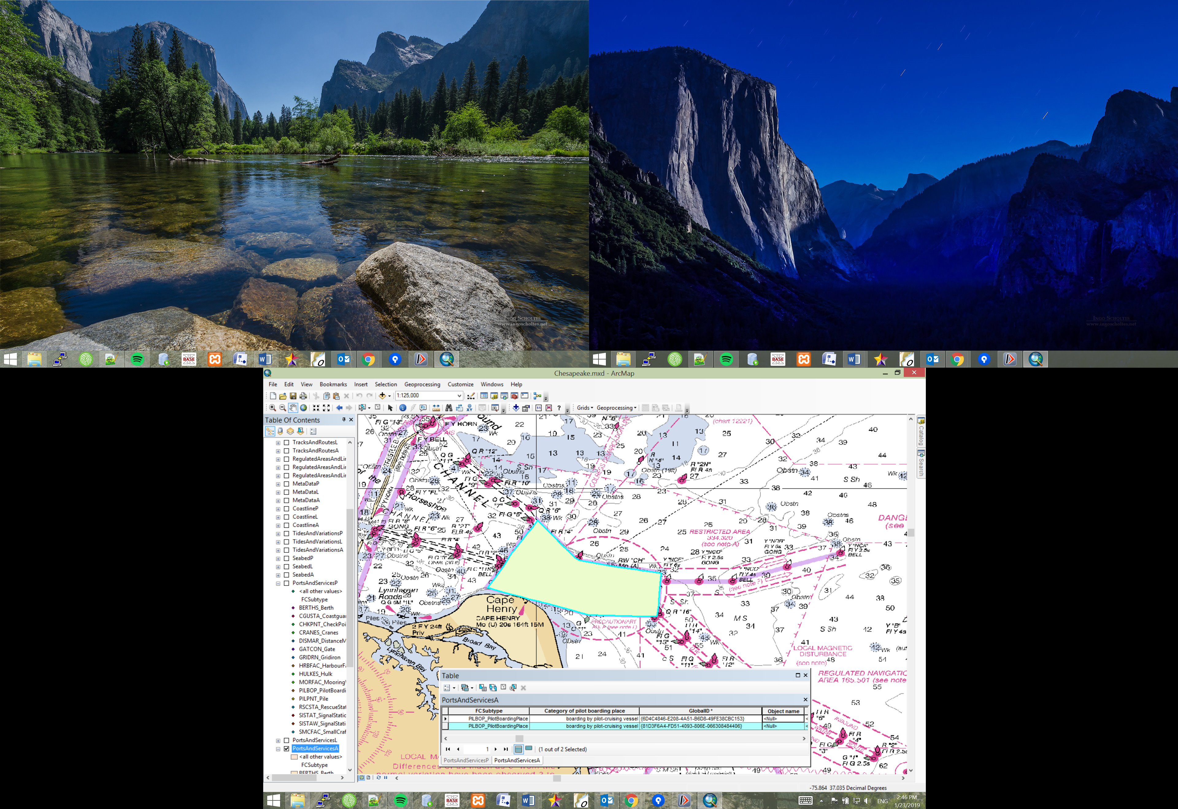

# Procedure for creating S-127 Pilotage info from Coast Pilot

## Identify S-127 components in Coast Pilot text

This key is very helpful in marking up the text.

ContactDetails

Authority

Applicability/permissionType

PilotDistrict

PilotService

PilotBoardingPlace

The Pilot Boarding Places should already be in the ENC, use ArcGIS to find them. Save the dataset name and longname field and use it as the gml identifier. (This way we can still find where the item came from, this may need some iterations as the ENC team at NOAA weigh in).

NOTE: there are Pilot boarding places not in the ENC that are listed in the Coast Pilot. One source told me that only pilots would use those boarding places and that the ship crew would only need to see the ENC related ones where they need to navigate to. There is an argument to include all the data in case the pilots end up using this data, as ideally we have the data and should mark it all up and let everyone else decide if they want to use it or not. So, this example data will include all of the information given about all pilot services/boarding places.

Use a tool like: <https://developers.google.com/maps/documentation/utilities/polylineutility> to drop markers down at each location and help to create a service area for all the places needed.

Highlighting CP text as you go helps to determine what has been accounted for in the XML. (Ideally, this will be entered into form fields that will populate the database…that will then create the S-127 GML.)

## Double checking even when valid and well-formed.

The data file could have no errors but still not be the best most useful file if the associations are completed wherever they can be. In other words to make sure everything is linked so the fullest possible picture of the networked services can be understood.

So make sure to verify the following:

### ASSOCIATIONS

1. All Authorities have an associated contact detail (theContactDetails). (These should be cross-checked with each other for consistency.)
2. All contact details have an associated authority (theAuthority) (these should be cross-checked with each other for consistency.)
3. All the permissionTypes have an invInformationAssociation to the applicable pilot district. (These should be cross-checked with each other for consistency.)
   1. And the referenced pilot districts should in turn have “permissions” pointing to the permission type.
4. All the permissionTypes “permission” attributes should link to an “applicability”. (These should be cross-checked with each other for consistency. Making sure all are used.)
5. The pilotage district “consistsOf” all the associated pilot boarding places.
   1. And likewise make sure that all of the pilot boarding places are associated with (a componentOf) a pilotage district.
6. That the pilotage districts also list all the possible serviceProviders
   1. Verify that each serviceProvider lists the pilotage district it belongs to with the serviceArea association.
   2. NOTE: the serviceArea will link to a pilot district AND link to a pilot boarding area (according to the schema/UML)
7. Pilot boarding places need to have
   1. One componentOf association with the pilotDistrict id
   2. A list of serviceProviders using the id for pilotService;
   3. Also verify all pilotServices associate to all the related pilot boarding places.
8. Any service hours are associated with the appropriate service and authority
   1. Also make sure the authorities and services have the appropriate hours associated.
9. Make sure all roles for all associations are listed using the xlink:arcrole attribute.